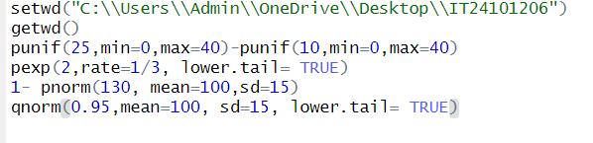**IT24101206 – LAB 07**

